**HTML src attribute**

Last Updated : 27 Mar, 2024

The**HTML src attribute**specifies the URL or file path of an external resource, such as an image, video, audio file, or script, to be embedded or referenced within a webpage.

**Syntax:**

<element src="url">

**HTML src attribute Supported tags**

| **Tag** | **Description** |
| --- | --- |
| [<audio>](https://www.geeksforgeeks.org/html-audio-src-attribute/) | Embeds sound content for playback in a webpage. |
| [<embed>](https://www.geeksforgeeks.org/html-embed-src-attribute/) | Integrates external applications or content. |
| [<iframe>](https://www.geeksforgeeks.org/html-iframe-src-attribute/) | Embeds another HTML document within the current one. |
| [<frame>](https://www.geeksforgeeks.org/html-frame-tag/) | Deprecated. Divides the browser window. |
| [<img>](https://www.geeksforgeeks.org/html-img-src-attribute/) | Embed images for display. |
| [<input>](https://www.geeksforgeeks.org/html-input-src-attribute/) | Creates interactive control elements in forms. |
| [<script>](https://www.geeksforgeeks.org/html-script-src-attribute/) | Embeds or links to external scripts. |
| [<source>](https://www.geeksforgeeks.org/html-source-src-attribute/) | Specifies alternative media resources. |
| [<track>](https://www.geeksforgeeks.org/html-track-src-attribute/) | Provides text tracks for multimedia elements. |
| [<video>](https://www.geeksforgeeks.org/html-video-src-attribute/) | Embeds video content for playback in a webpage. |

**Attribute Values**

It contains a single value URL that specifies the link of the source file. There are two types of URL links which are listed below:

| **Term** | **Description** |
| --- | --- |
| Absolute URL | Points to a resource outside the current website/domain. |
| Relative URL | Points to a resource within the same website/domain. |

**Example of HTML src attribute**

**Example 1:** In this example we displays GeeksforGeeks heading and an audio player with multiple source files for playback control.



1

<!DOCTYPE html>

2

<html>

3

<head>

4

<title>

5

HTML audio src Attribute

6

</title>

7

</head>

8

​

9

<body style="text-align:center;">

10

11

<h1 style="color:green">

12

GeeksforGeeks

13

</h1>

14

15

<h2>

16

HTML audio src Attribute

17

</h2>

18

19

<audio controls muted>

20

<source src="GFG.mp3" type="audio/mp3">

21

<source src="GFG.ogg" type="audio/ogg">

22

</audio>

23

</body>

24

</html>

**Output:**

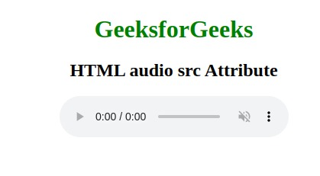

**Example 2:** In this example image linked via the “src” attribute with an alternative text.



1

<!DOCTYPE html>

2

<html>

3

​

4

<head>

5

<title>

6

HTML img src Attribute

7

</title>

8

</head>

9

​

10

<body>

11

<h1 style="color:green">

12

GeeksforGeeks

13

</h1>

14

​

15

<h2>HTML img src Attribute</h2>

16

​

17

<img src=

18

"https://media.geeksforgeeks.org/wp-content/uploads/20190506164011/logo3.png"

19

alt="GeeksforGeeks logo">

20

</body>

21

</html>

**Output:**

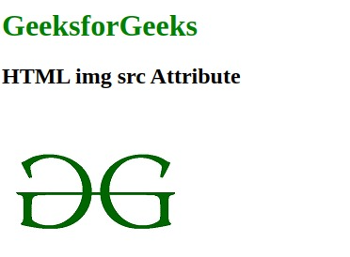

**Supported Browsers:** The browsers supported by **HTML src attribute** are listed below:

* [Google Chrome](https://www.geeksforgeeks.org/google-chrome-browser/)
* [Edge](https://www.geeksforgeeks.org/microsoft-edge-browser/)